Multifarious Systems 1

ECE 3553

FINAL PROJECT REPOR

# Pulkit Aggarwal

901873039

# Purpose

The purpose of this project to apply all the concepts learned in the course ECE 3553- Multifarious Systems 1. This course covers various technologies that involve web development, such as PHP, HTML5, SQL, JavaScript and CSS. This project utilizes all the technologies to create a web application that users can use to make reservations for a movie theater ideally. The web application has a lot of features and functionalities such as fancy graphical user interface, List of movies now showing, a description of the movies that are now showing, make a reservation via filling a form, get a unique code on making a reservation, using the confirmation code to retrieve the details of the reservation and finally a pop up menu that displays contact information.

# Results

Figure Home Page Showing Titles

# 

Figure 3 Pop up window that shows the contact information

# 

Figure A box showing description on click on the picture

# 

Figure 4 The reservation form

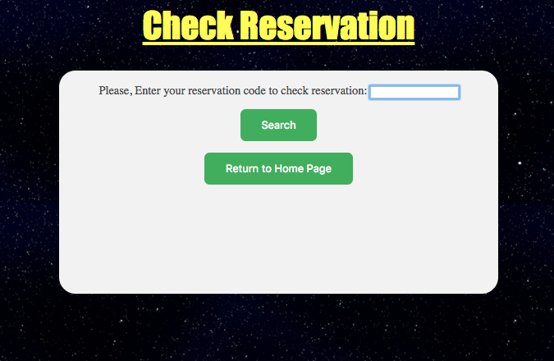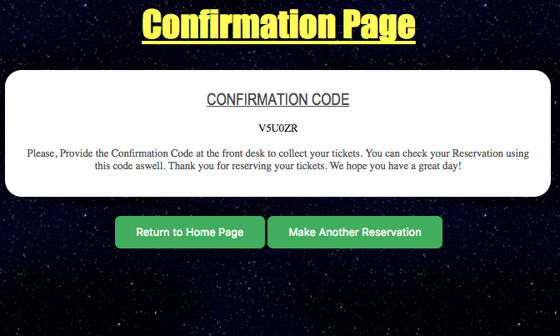

Figure 6 Check reservation form

Figure 5 The automatic code generated upon submission

# 

Figure 7 When reservation exists

# 

Figure 8 When incorrect code entered

# 

Figure 9 The reservation table on phpMyAdmin

# 

Figure 10 The data stored when form submitted

# Conclusion

In this final project, a Movie Ticket Reservation system was created. The five technologies used in this project were CSS, HTML, SQL, JavaScript, and PHP. The features of this system came out to be successful that were inputted. It was a great experience, experiment and trying the vast scope of these technologies and apply the knowledge and understanding that was gained during the labs and the classes. It helped me in improving my coding skills to a greater level, and simultaneously got me engaged in working on a project